**Chapter 19 Programming Assignment**

By Reno Redaja

**Project 19.1**

Write a program that returns the largest item in an Array List. Create a method based on the following method header:

public static <E extends Comparable<E>> E max(ArrayList<E> list)

In your main() method, test your max() method by creating two different types of ArrayLists (for example, one that stores Strings and one that stores Integers).

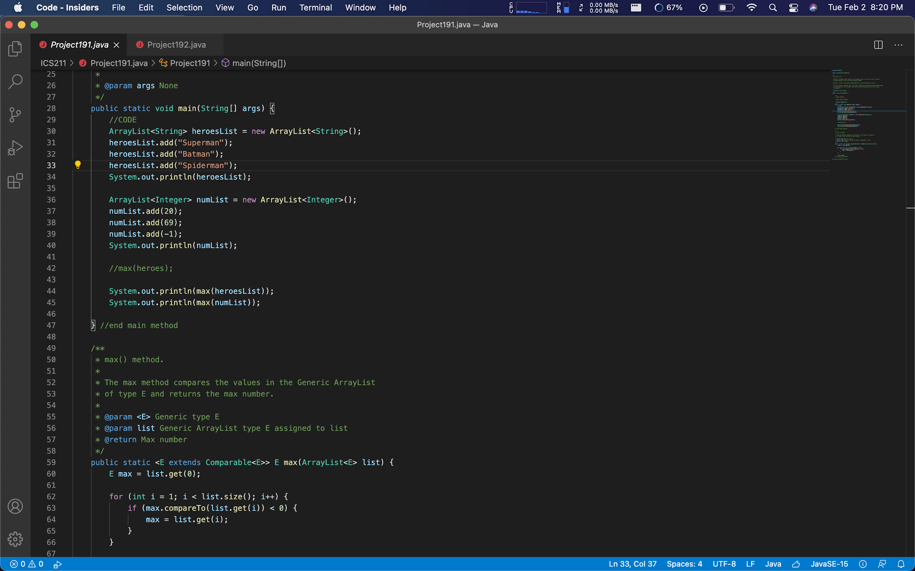

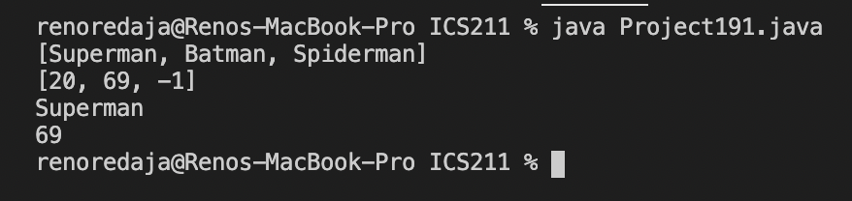

My program meets Project 19.1 requirements because it uses a Generic type that used the Comparable interface. With the max() method it searches through the list and compares the values. If it is the biggest value, return it from the list (as shown in the terminal).

**Project 19.2**

Create a method that returns a new ArrayList, containing non duplicate elements from the original ArrayList. Your method should be based on the following method header:

public static <E> ArrayList<E> removeDuplicates(ArrayList<E> list)

You may add this method into the Java class you created for Project 19.1, and use the same ArrayLists to test your new method. Just ensure that your original ArrayLists contain some duplicates.

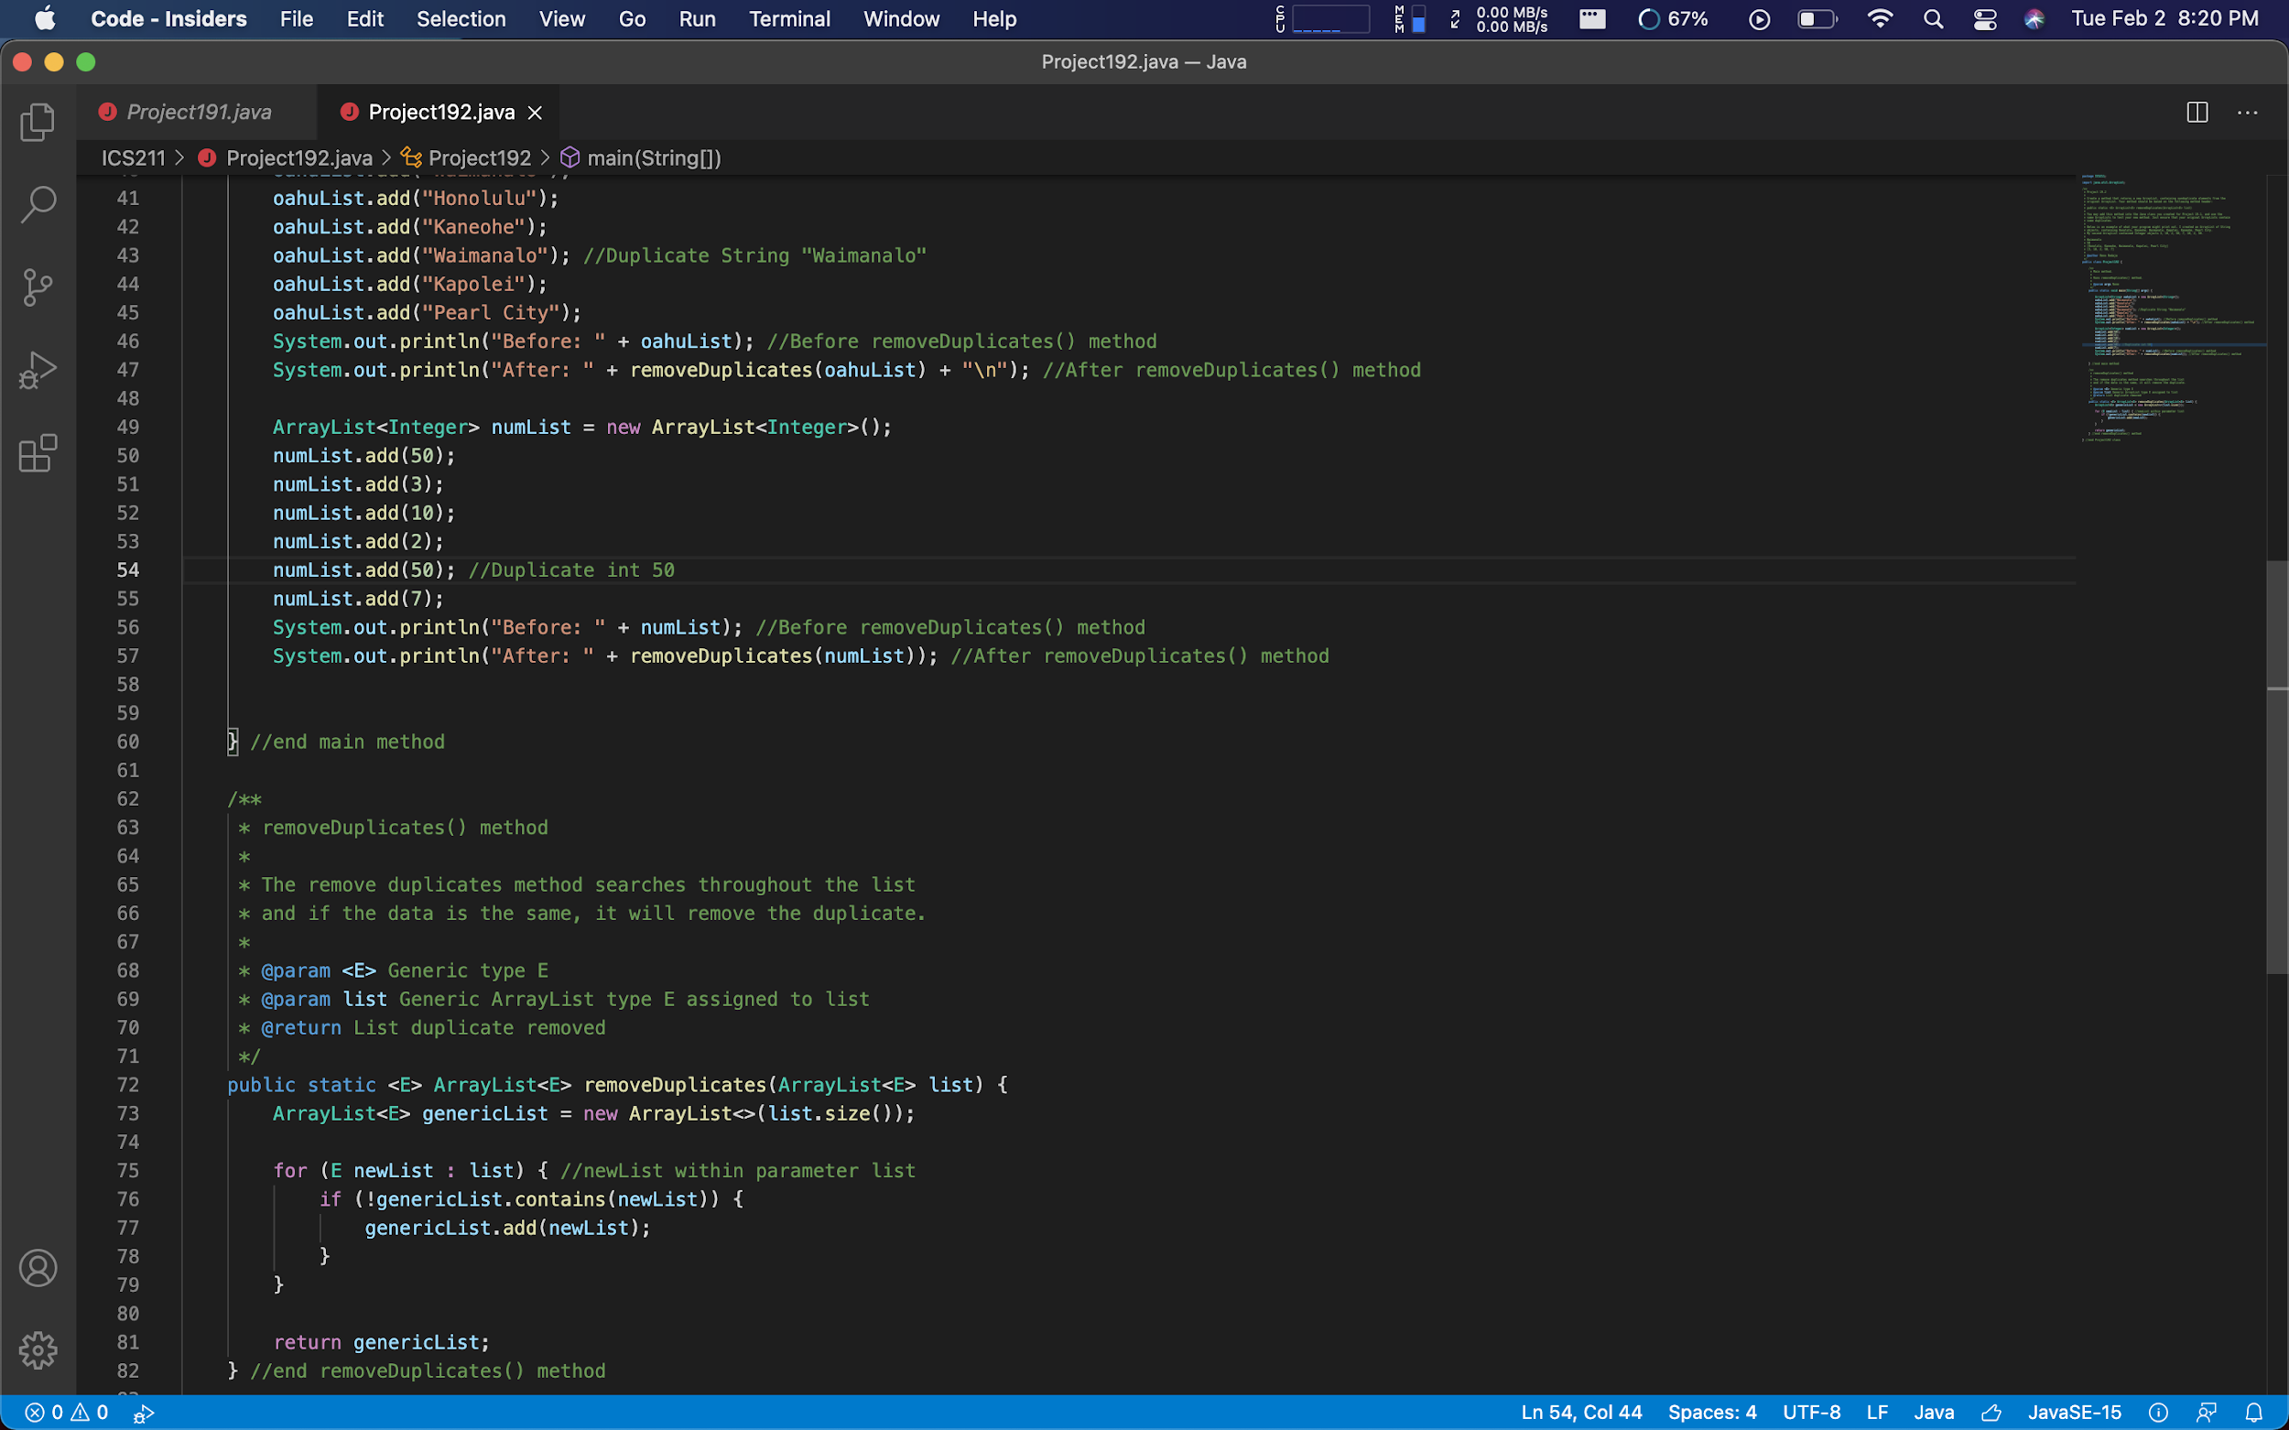

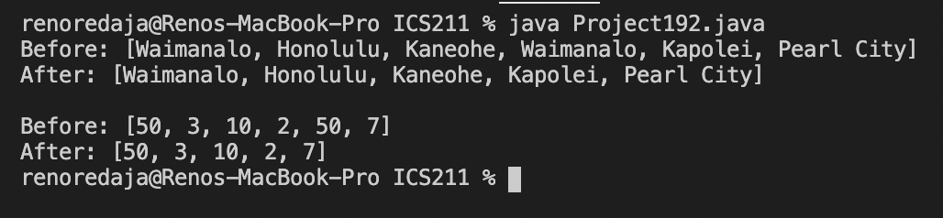

My program meets Project 19.2 requirements because it uses Generic type to search within a Generic ArrayList to find if there is a value that is the same then removes that value. In the main method, there is an example using String & Integer types. Shows a before and after using the removeDuplicate() method.